C PROGRAMMING
NAME : VISHAAL G
REG NO : 1921260043
COURSE CODE : CSA0222
Task 9: Implement and Test the Billing Program
9.1 Complete billing program
This version uses integer paise, handles a single 16-bit meter rollover and validates the input. 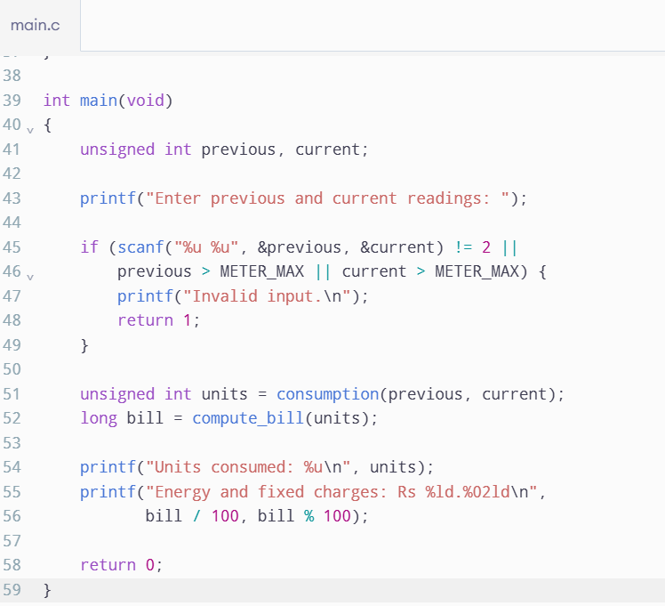
Important limitation: This code assumes a 16-bit meter and interprets every decreasing reading as a rollover. A real billing system should verify the meter's rollover rules and flag suspicious readings. Also, the use of unsigned subtraction is valid here because the readings are constrained to the range 0–65,535.
9.2 Test table
Test case | Previous | Current | Units consumed | Expected bill
Zero consumption | 1000 | 1000 | 0 | ₹50.00
Exactly 100 units | 1000 | 1100 | 100 | ₹50.00
Exactly 200 units | 1000 | 1200 | 200 | ₹275.00
350 units | 1000 | 1350 | 350 | ₹950.00
Rollover | 65400 | 120 | 256 | ₹527.00
For the rollover case:
\[ \text{Units}=65536-65400+120=256 \]
\[ \text{Bill}=50+(100\times2.25)+(56\times4.50) \]
\[ \boxed{\text{Bill}=\text{₹527.00}} \]
These are calculated expected results; record the actual output after executing the program.
9.3 Five-bill total
Consider five households consuming 0, 100, 150, 200 and 350 units.
Units | Bill
0 | ₹50.00
100 | ₹50.00
150 | ₹162.50
200 | ₹275.00
350 | ₹950.00
Total | ₹1,487.50
9.4 Alternative: tariff arrays
Tariff limits and rates can be stored in arrays and processed using a loop. For \(s\) slabs, the calculation takes \(O(s)\) time and uses \(O(s)\) space for the tariff data. This approach is easier to extend when the number of slabs changes. For three fixed slabs, explicit conditions are simpler.

